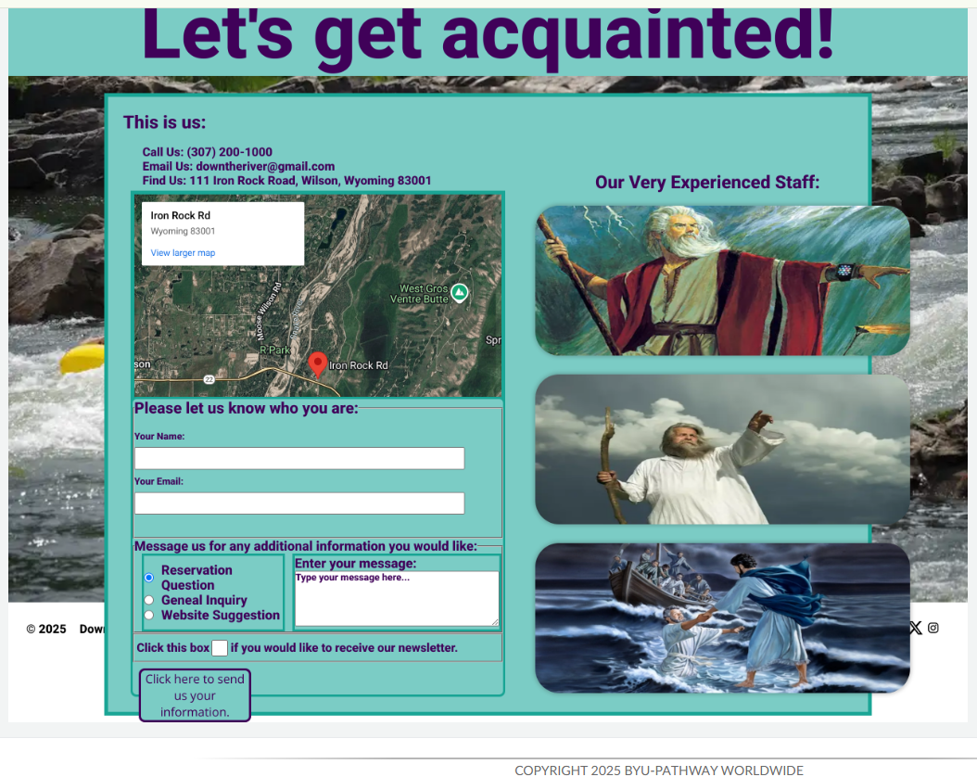
This is what I see in the “snapshot. I agree that the footer is completely covered by the “main” and the images are out of alignment as is the submit button.

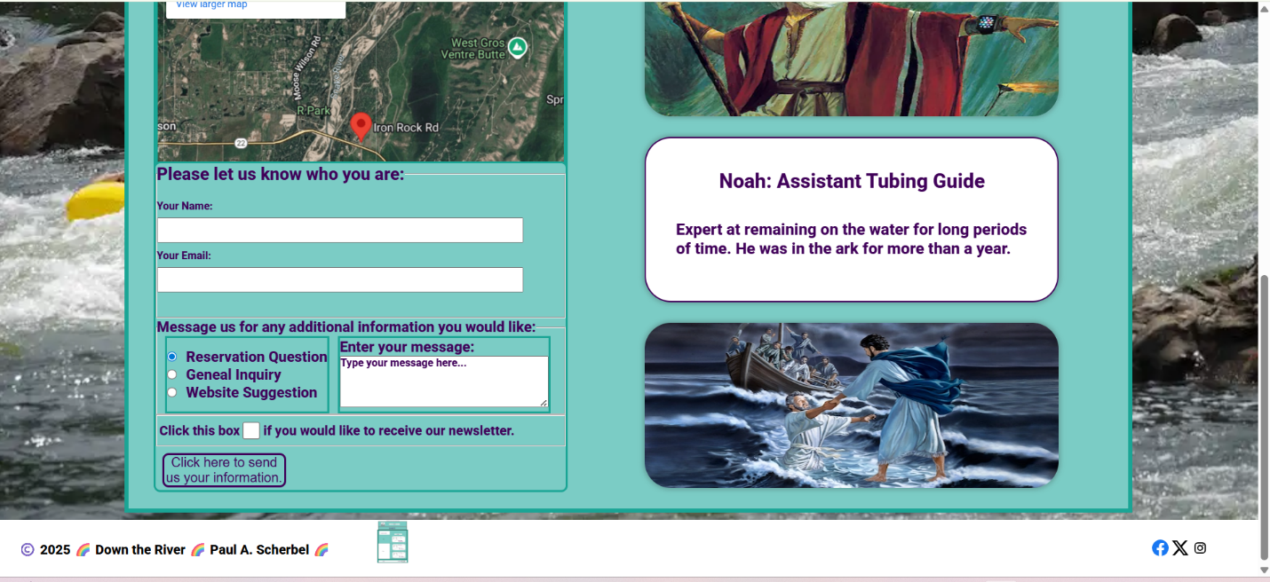
However, this is what I see when I view the same webpage in my browser at zoom 100%. The footer is completely visible and the photo is flipped over so the title and description can be seen.

